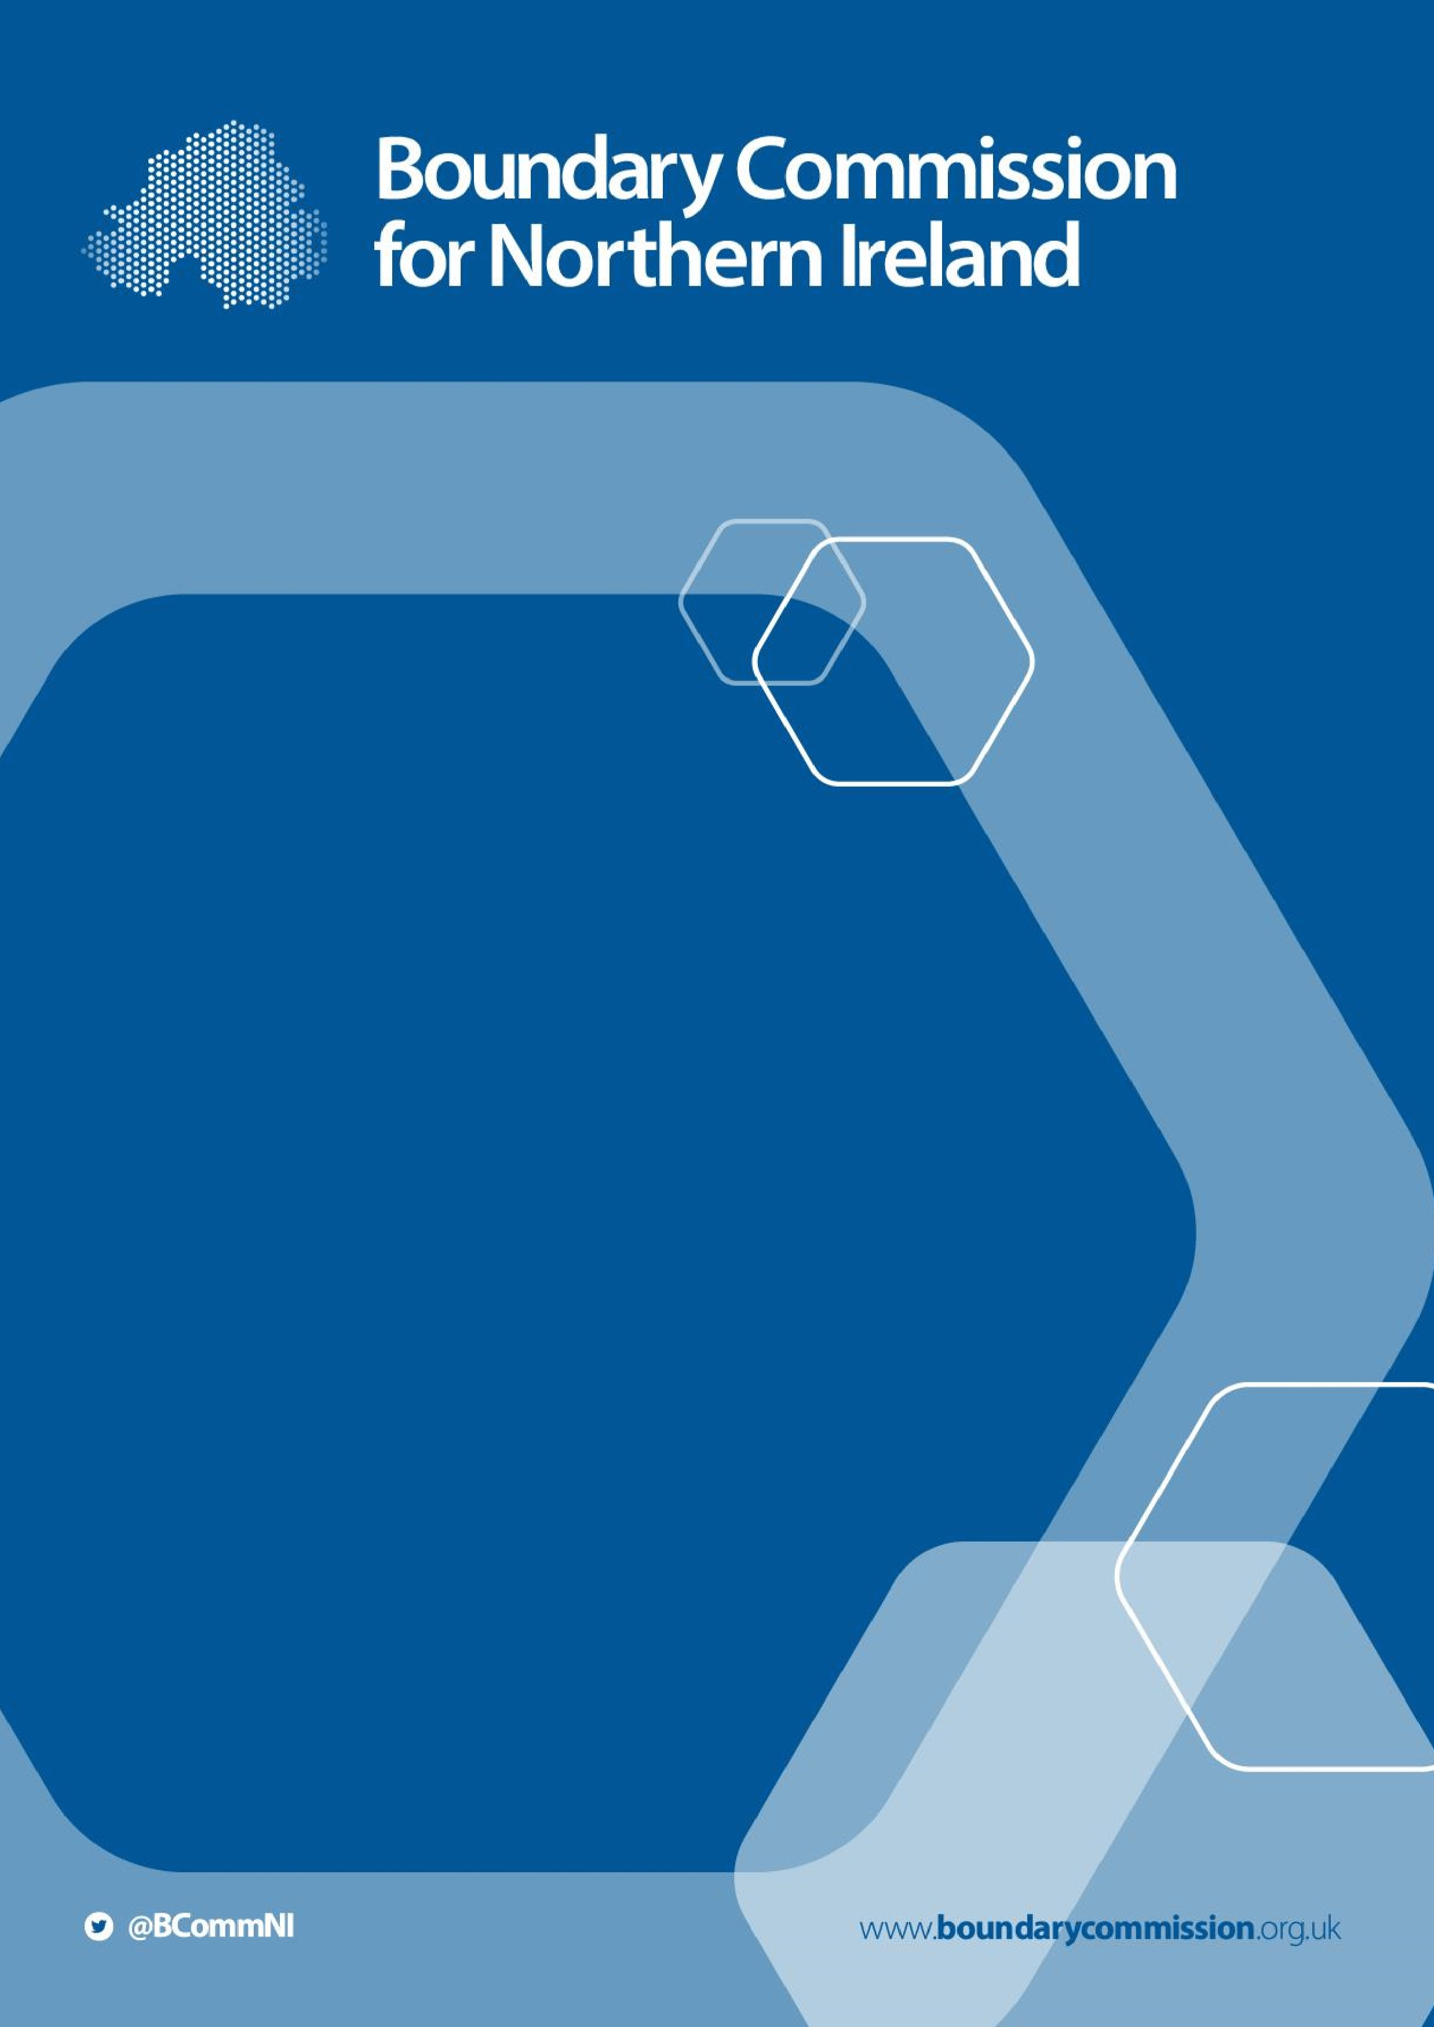

**2023**

**Review of**

**Parliamentary**

**Constituencies**

**Progress Report**

**2021**

**January 2022**

**2023 Review of Parliamentary**

**Constituencies**

**Progress Report**

**2021**

Presented to Parliament pursuant to Section 3(2C) of the

Parliamentary Constituencies Act 1986, as amended by the

Parliamentary Voting System and Constituencies Act 2011 and Parliamentary Constituencies Act 2020.

© Crown copyright 2022

This publication is licensed under the terms of the Open Government Licence v3.0 except where otherwise stated. To view this licence, visit

<http://www.nationalarchives.gov.uk/doc/open-government-licence/version/3>

Where we have identified any third-party copyright information you will need to obtain permission from the copyright holders concerned.

This publication is available a[t www.boundarycommission.org.uk](http://www.boundarycommission.org.uk/).

Any enquiries regarding this publication should be sent to us at:

Boundary Commission for Northern Ireland

The Bungalow

Stormont House

Stormont Estate

Belfast

BT4 3SH

Email: contact@boundarycommission.org.uk

Rt Hon Sir Lindsay Hoyle MP

Speaker’s Office

House of Commons

London

SW1A 0AA

28th January 2022

Dear Mr Speaker,

1. As required by section 3(2B)(a) of the Parliamentary Constituencies Act 1986 (as amended), hereafter referred to as ‘the Act’, each Boundary Commission must submit a report to the Speaker of the House of Commons each January setting out the progress made with the preparation of the “pending boundary report”. Section 3(2C) of the Act requires the Speaker to lay this report before Parliament.

1. We have set out below the key actions that we have undertaken since the review commenced in January 2021. These actions have been undertaken in the context of the ongoing COVID-19 pandemic, the impacts of which we continue to keep under review. Notwithstanding, the Boundary Commission for Northern Ireland is on course to deliver our Final Recommendations for the 2023 review to you within the statutory period stated in the Act of ‘before 1st July 2023’.

# Start of the review

3. Along with our counterpart Commissions in England, Scotland and Wales, we formally commenced the 2023 Review on 5th January 2021, with the publication of the total UK electorate, electoral quota, and allocation of constituencies to each part of the UK. We publicised this information, noting that for the 2023 Review, Northern Ireland has been allocated 18 constituencies.

# Guide to the 2023 Review

4. The Commission decided that, as with previous reviews, we should publish a document to explain how the statutory process for the 2023 Review would work. The ‘Guide to the 2023 Review’ was published in May 2021 and contains information on the review process and how members of the public, political parties, and wider civic society can share their views. An Easy-Read version of the Guide has also been produced. Both documents were published on the

Commission’s website, with hard copies available on request.

# Political Parties’ Briefing

5. As with previous reviews, the Commission held a briefing for political parties and independents with representation at either Westminster or the Northern Ireland Assembly in May 2021, following publication of the Guide. The Deputy Chairman explained the role and remit of the Commission, the statutory rules within which it is required to work, the procedures it will follow and the proposed timetable. The meeting did not consider any boundary proposals. A note of the meeting was placed on the Commission’s website.

# Initial Proposals, publicity and public consultation

1. The Commission’s Initial Proposals for 18 constituencies in Northern Ireland were published on 20th October 2021, which marked the commencement of the initial consultation period. In line with Rule 2 in Schedule 2 of the Act, all 18 constituencies proposed had electorates within 5% of the electoral quota, this range being 69,724 – 77,062.

1. A map showing the Initial Proposals, along with information about how to participate in the consultation, was displayed in public libraries and local council premises across Northern Ireland, in line with s.5 (1) (a) (ii) of the Parliamentary Constituencies Act 1986 (as amended).

1. In order to further publicise the review, the Commission issued a press release alongside the publication of its Initial Proposals, which saw good uptake in the local press. We provided information and a range of resources via our website, including an interactive map of the Initial Proposals. We used social media to boost reach and provided an online consultation portal.

1. By the close of the initial consultation period on 15th December 2021, we had received 31 written representations. These representations were published on our website on 27th January 2022, just ahead of the start of the secondary consultation period, and in line with our statutory duties. A Guide to the Secondary Consultation Process, including the Public Hearings, was also published.

# Secondary consultation period and public hearings

1. The secondary consultation period will commence on 9th February 2022 and end on 23rd March 2022. It provides an opportunity to submit further written representations with respect to the representations from the initial consultation period. The secondary consultation period also includes a number of public hearings, at which oral representations can be made about any of the Commission’s initial proposals, and counterproposals can be presented or commented on.

1. Further details about the public hearings to be held in Northern Ireland, including dates, venues and how to register, will be made available on our website on 9th February 2022. We will also undertake further publicity in order to encourage engagement with the secondary consultation process, including utilising public display points at local libraries and council premises.

# Looking ahead

1. Following the end of the secondary consultation period, we will publish the records of the public hearings on our website. We will also publish the written representations received. Following the publication of these records and representations, there will be a further 4-week consultation period (the third consultation period) which we anticipate will commence in autumn 2022.

1. Having considered the written representations received during the initial and secondary consultation periods, and the records of the hearings, we will decide whether and to what extent we will revise our initial proposals. If we decide to revise our initial proposals, we will publish the revised proposals before the start of the third consultation period.

# Next report

14. In line with our statutory duties, we will submit a further progress report in January 2023 outlining the work undertaken on the review during 2022.

**Mr Justice Michael Humphreys**

**(Deputy Chairman)**

**Sarah Havlin**

**(Boundary Commissioner)**

**Vilma Patterson**

**(Boundary Commissioner)**

